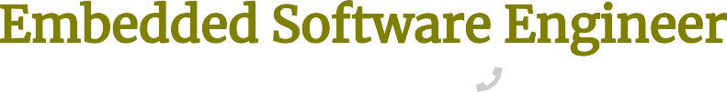
Dover, DE
salvador.sanz@email.com
(123) 456-7890
LinkedIn

Senior Embedded Software Engineer

Dice
2024 - current Dover, DE
- Architected firmware components for embedded monitoring systems supporting platform infrastructure, enabling telemetry collection across 18 distributed hardware nodes used in internal testing environments.
- Optimized memory management routines in C, reducing firmware footprint by 29% and improving device boot reliability during system initialization.
- Implemented diagnostic tooling for device health monitoring that accelerated fault isolation to under 6 minutes per incident for engineering teams.
- Collaborated with platform and hardware engineers to deliver firmware updates on a two-week development cycle, strengthening deployment consistency for internal devices.

Software Engineer III, Embedded Systems

Google
2020 - 2024 Dover, DE
- Designed embedded control software for hardware subsystems powering large-scale infrastructure devices, enabling coordination across 25+ integrated sensors and peripherals.
- Refactored device communication layers in C++, cutting command processing latency by 44% in hardware validation environments.
- Developed automated validation frameworks that improved firmware regression detection across 7 critical platform modules before release.
- Partnered with hardware, reliability, and production teams to deliver firmware revisions aligned with quarterly hardware release milestones.

Research & Development Embedded Software Engineer

Superpedestrian
2016 - 2020 Dover, DE
- Built embedded control algorithms supporting electric scooter safety systems, enabling real-time monitoring of 12 onboard sensors during field testing.
- Prototyped firmware features in C for battery management and motor control, reducing energy consumption by 16% during extended ride simulations.
- Investigated anomalous telemetry signals from prototype vehicles, resolving faults impacting three experimental hardware revisions.
- Documented embedded testing procedures and debugging workflows that shortened hardware bring-up time by one development sprint.
Proven and hard-working embedded software engineer with 10+ years of experience. My passion is combining clean and scalable code with cutting-edge physical hardware, and I am eager to solve creative problems for Oracle consumers to create an improved user experience.

Bachelor of Science Computer Science

Carnegie Mellon University
2012 - 2016
Pittsburgh, PA

- C / C++
- Embedded Systems Development
- RTOS
- Hardware Interface Protocols (SPI, I2C, UART)
- System-Level Problem Solving
- Cross-Functional Collaboration
- Technical Documentation
- Iterative R&D Development

